**ASSIGNMENT 2**

|  |  |
| --- | --- |
| **Assignment Date** | **9 November 2022** |
| Student Name | SARAVANAN J |
| Student Roll Number | 715319106014 |
| Maximum Marks | 2 Marks |

**Introduction**

I have chosen this topic to spotlight on one of the most technological trend these days known as AI (Artificial Intelligent). Therefore; I will discuss some of the most important aspects related to AI in which it will help in a better understanding of Artificial Intelligent and both its advantages and disadvantages to be able to protect ourselves from the upcoming technological trend. This paper will also discuss some of the used in AI systems.

**Pros and Cons of Artificial Intelligence**

AI offers reliability, cost- effectiveness, solve complicated problems, and make decisions; in addition, AI restrict data from getting lost. AI is applied nowadays in most fields whether business or engineering. One of the great tools in AI is called reinforcement learning which is based on testing success and failure in real life to increase the reliability of applications Unfortunately, AI is limited with its capability and functionality. Although Artificial Intelligence made our lives much easier and saved us more time than ever, scientists are predicting that by the huge dependency on AI humanity could extinct. Scientists argue that by having a AI machines, people will be jobless and that will the sense 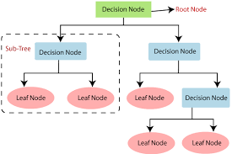

**AI Design Models**

AI application are a lot around us and in this paper, I will discuss some of the application of AI that we always use nowadays which is Virtual Assistants. Over the past few years smart assistants are becoming a very common technology in most of the smart devices and most importantly, that these assistants are getting smarter than ever. In addition to the awesome help they provide us with, is that every one of these apps has unique features.

**Some Applications on Artificial Intelligence**

AI can be designed using lots of algorithms. These algorithms help the system to determine the expected response which will basically tell the computer what to expect and work accordingly.

* Voice recognition

*Virtual agents

* Machine learning platform

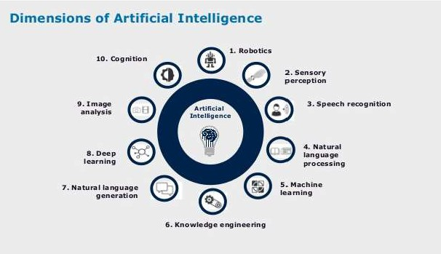

**AI demands engineering discipline**

Companies need to embrace AI holistically to address the scaling problem—rooting it in business strategy, innovation, and competitive differentiation, then deeply integrating it into evolving business operating models and workflows. Artificial Intelligence works according to the following phases: getting data m, clean/manipulate/ prepare the data, train model, test data, and improve the data as mentioned Before accessing the data, a business must verify the quality of the data to ensure that it meets the requirement.

**Conclusion**

AI nowadays is being implemented in almost every field of study through several models such as SVM and ANN. We should be able to proceed with knowing and understanding the consequences of every technology trend. Adopt into this change and welcome it too by embracing AI and moving toward a better society.

